**VANESSA TANNOUS**

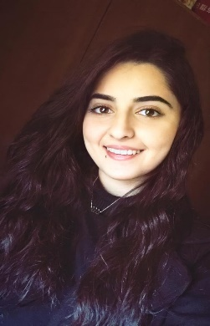 **BIOCHEMIST**

**Address:** Ardeh-Zgharta, North Lebanon

**Phone:** +961 76 378 178

**Email:** vanessatannous4@gmail.com

**Nationality:** Lebanese

Summary

An entry-level biochemist. Results-oriented, with a goal to always deliver the most clean and efficient work. Constantly thriving to develop oneself and learn new skills. Currently seeking a position in the field, where I can apply my knowledge in making a significant success to the company and be more involved in research.

Experience

**Tutor at ASES Center (After School Education Services)**  **August 2022-Present**

**Part Time Job, Branch: Zgharta**

* Teaches biology/chemistry for intermediate (Grade 7,8,9) and High school students.

**Training at ASES Center (After School Education Services)** **July 2022-August 2022**

* Biology and chemistry teacher for high school students.

**Private Teacher February 2019-June 2022**

* Provide educational assistance to elementary (Grade 1 to 6) and secondary students.

**Internship Laboratory Department at CHN Hospital**  **October 2021-February 2021**

* Sections: Microbiology, Hematology, Immunology, Biochemistry, Blood banking.

Education

**Master 1 in General Biochemistry**  **Present**

Lebanese University Faculty of Sciences Branch 3, Rasmaska Al Koura

**Bachelor in Biochemistry 2018-2021**

Lebanese University Faculty of Sciences Branch 3, Rasmaska Al Koura

Volunteering

**Coordinator at CentreMINE March 2021-Present**

**Campus Director by Hult Prize Foundation December 2021-March 2022**

Workshops/Seminars

**Bloodborne Pathogens Online Course January 2021**

**CPR, AED and First Aid Online Course January 2021**

Administered by National Health Care Provider Solutions + Certificate of completion

Skills & Expertise

|  |  |
| --- | --- |
| * Communication & Interpersonal * Teamwork & Time Management * Analytical Thinking * Problem-Solving & Negotiations * Microsoft Excel, Word and PowerPoint * Reports & Documentation |  |

Languages

**Arabic:** Native | **French**: Fluent | **English:** Good